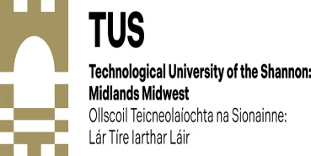 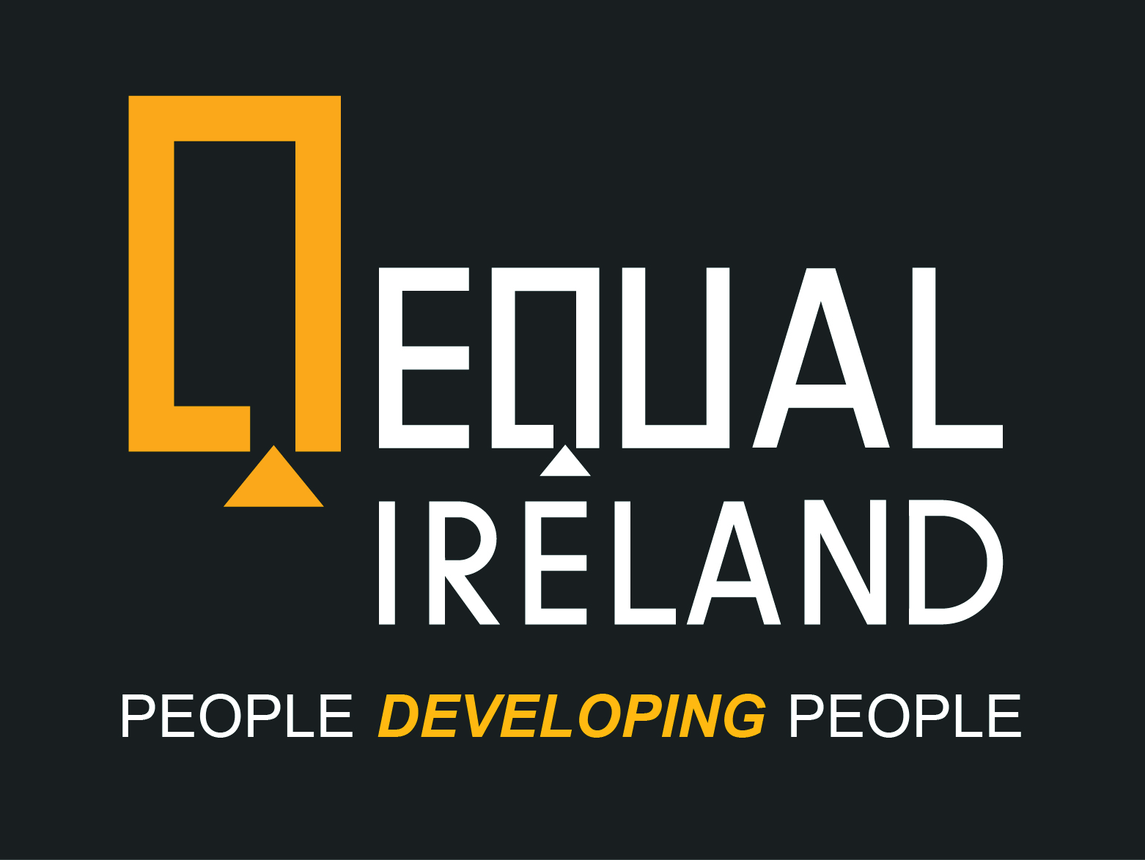

**Unlock Your Potential in Social Enterprise and Community Development**

**Earn Your Higher Certificate or BA with QQI Level 6 and Level 7 Programmes**

**Offered by TUS Midlands and EQUAL Ireland**

We are delighted to announce that enrolment is now open for our online Level 6 Higher Certificate in Social Enterprise and Community Development and our Level 7 BA in Business, Enterprise, and Community Development. These courses will commence on September 7th, 2024, in collaboration with TUS Athlone.

**These Courses Might be Just what you Need!**

* **Tailored for Adult Learners**: Ideal for individuals passionate about Business, Social Enterprise, or Community Development, taught by adult education experts, with extensive practical experience in the field.
* **Flexible Online Learning**: Live interactive workshops which are also recorded fitting your busy schedule, allowing you to study at a time pace and place that suits you.
* **Accredited by TUS Midlands**: Gain a recognised qualification - Higher Certificate at Level 6 or a BA at Level 7 (duration 1 year).
* **Support for All Applicants**: Where you do not have the required qualifications but do have experience and hands on learning we can assist you with your application through RPL (Recognition of Prior Learning) Please ask?

**Would you like to find out more?**

We invite you to join one of our online information sessions to learn how these programmes can enhance your career and community impact. Sessions will be held on:

* **Saturday, June 15th, at 12 noon via zoom**

*“For years I wanted to be active in my community but didn’t have the confidence**to put myself forward. What I learned most of all from learning with EQUAL Ireland is that we depend so much on each other, we can ask for help and support and now for me anything is possible and I am a recognised Leader in my Community and making a real contribution, all thanks to EQUAL Ireland!”*

* **Monday, June 17th at 6.30 p.m. via zoom**
* **Saturday, June 22nd, at 12 noon via zoom**
* **Saturday, June 29th, at 12 noon via zoom**

**Get Started Today:**

Contact us to schedule a call back or to reserve your spot in one of our information sessions. Don’t miss this opportunity to advance your education and make a significant difference in your community.

For more details and to enrol, contact [eoin@equalireland.ie](mailto:eoin@equalireland.ie) or [eddie@equalireland.ie](mailto:eddie@equalireland.ie)

***Regards***

***Nuala and Eddie***

***EQUAL Ireland***

***00 353 (0)87 2237231***

***eddie@equalireland.ie***

***Programme Brochures visit:*** [***www.equalireland.ie***](http://www.equalireland.ie/)

**People *Developing* People**